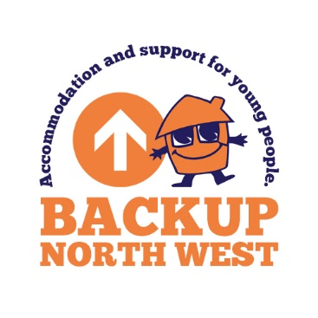

**SPONSORSHIP FORM**

## Join us and help to prevent

## youth homelessness in

## our community

On: 15/11/2024

Name:

I am taking part in: **BACKUP SLEEPOUT**

**How to return your sponsorship form and money**

By Cheque to: By BACS:

**Backup North West** Sort code: 08-90-18

Ground and 1st floor Acc no: 70966608

Bridgeman House

77 Bridgeman Street (please reference your name and event)

Bolton BL3 6BY Cooperative Bank Backup North west

**For help and advice on your fundraising activities please email** [**fundraising@backup-charity.org**](mailto:fundraising@backup-charity.org)**.uk or**

**call Claire on**

**01204 520183**

|  |
| --- |
| Name: |
| Address: |
| Email: |
| Telephone no: |
| Total amount enclosed: |

**We would like to stay in touch with you**

Without your support, we can’t continue our work in preventing

youth homelessness.

We want to let you know about the difference you are

making to our young people’s life and other opportunities

that you can get involved with such as fundraising,

volunteering and other campaigns. If you are happy

Here is how the money you raise will support

our young people and help them forge a better future for themselves.

to forge a better future for themselves.

to receive this information, please let us know how

you would prefer to hear from

**people and help them to forge a better future for themselves.**

**Email: Yes No**

* **£5** will pay for a meal for a young person at our Loft House Project
* **£10** Will pay for a week’s electric for a young person
* **£30** will pay for a startup pack including food and drink for our young people
* **£60** will pay for an emergency overnight stay for a young person

111111

**Post: Yes No**

**Phone: Yes No**

**SMS: Yes No**

## Did you know you can collect sponsorship money online?

On: 15.11.24

I am taking part in: **BACKUP SLEEPOUT**

Name:

**Boost your donation by 25p for every**

**£1 you donate at no extra cost to you.**

**at no extra cost to you.**

If you have ticked the Gift Aid √ box, I confirm that I am a UK taxpayer. I have read this statement and want Backup to reclaim tax on the donation detailed below, given on the date shown. I understand that if I pay less income tax and/or Capital Gains tax then the amount of Gift Aid claimed on all my donations in that year is my responsibility to pay any difference. I understand that Backup will claim 25p of tax on every £1 that I have given.

Setting up your own personalised sponsorship page online is a quick, easy and secure way for people to support you. For more details, visit

https://www.justgiving.com/campaign/backupsleepout

|  |  |  |  |  |  |  |
| --- | --- | --- | --- | --- | --- | --- |
| **First Name** | **Surname** | **House no or name**  **For Gift Aid we can only accept your home address** | **Postcode** | **Amount**  **£** | **\*GIFT**  **AID**  **√** | **Date collected** |
| i.e. John | Smith | 1, Any Street, Bolton | Bl3 7hn | £10 | √ | 22.08.24 |
|  |  |  |  |  |  |  |
|  |  |  |  |  |  |  |
|  |  |  |  |  |  |  |
|  |  |  |  |  |  |  |
|  |  |  |  |  |  |  |
|  |  |  |  |  |  |  |
|  |  |  |  |  |  |  |
|  |  |  |  |  |  |  |
|  |  |  |  |  |  |  |
|  |  |  |  |  |  |  |
|  |  |  |  |  |  |  |
|  |  |  |  |  |  |  |
|  |  |  |  |  |  |  |
|  |  |  |  |  |  |  |
|  |  |  |  |  |  |  |
|  |  |  |  |  |  |  |
|  |  |  |  |  |  |  |
|  |  |  |  |  |  |  |

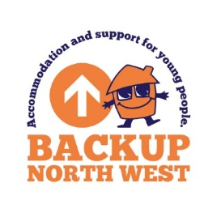

Reg charity no 1064698



**Total £**

**Thank You**