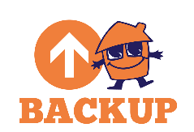
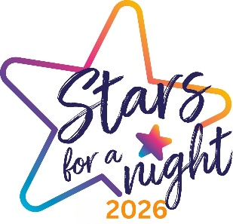
INDIVIDUALS AUDITION FORM
Thank you for auditioning for the Bolton Talent Competition, supported by Backup North West. Please complete and return this form to: stars@backup-charity.org.uk to register your audition. Video files should be sent via a WeTransfer link. Participants must be 14 or over. Further T&Cs can be found on the Backup website. Good luck!

First Name* Last Name*

Email Address* Phone Number*

I’d like to receive communications from Backup in future.

Date of Birth* (DD/MM/YY)

Type of Act* (singing, dancing, comedy, magic etc.)

Name of Act (if applicable)

Audition Tape Link* (links should be generated through WeTransfer)

Parent or Guardian Name (under 18s only)

Parent or Guardian Phone Number (under 18s only)

