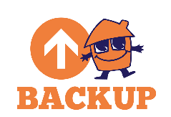
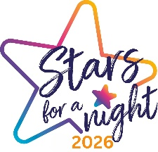
GROUP AUDITION FORM
Thank you for auditioning for the Bolton Talent Competition, supported by Backup North West. Please complete and return this form to: stars@backup-charity.org.uk to register your audition. Video files should be sent via a WeTransfer link. Participants must be 14 or over. Only one Group Audition Form needs to be submitted per group. Further T&Cs can be found on the Backup website. Good luck!

Name of Group*

Type of Act* (singing, dancing, comedy, magic etc.)

Audition Tape Link* (links should be generated through WeTransfer)

Number of Group Members* Are any members of your group under 18?*
Please note, any members of your group under 18 years of age should each complete an Individuals Audition Form, to be submitted alongside this Group Audition Form.

Please List All Group Members Names in Full*

Main Contact Details
Please assign a main point of contact for your group.
First Name* Last Name*

Email Address* Phone Number*

I’d like to receive communications from Backup in future.

