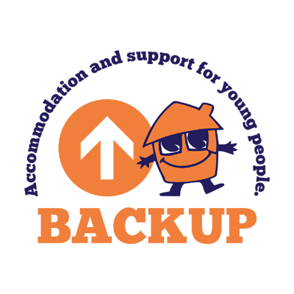

BACKUP North West delivers support and housing services for homeless and vulnerable young people in Bolton.

Fundraising and Events Coordinator
Salary Starts at £28,681 per annum
37 hours a week
We need a new Fundraising and Events Coordinator to join our growing team. Backup is an award winning and ambitious charity working with young people trapped in housing crisis, homeless, with huge support needs. Join our team and make a real difference to young people and give them better futures.

The role is full time but you need to be flexible around the timing of events and commitments. We will ensure you are fully supported, have access to training and development in a culture of positivity and optimism.

To join us, you will have to demonstrate a commitment to creating life chances for highly disadvantaged young people, THIS IS A MUST. It is desirable to hear from candidates with a) previous charity experience but not essential because we need someone with flair, an eye for detail, some sales acumen, great with people and maintaining relationships with integrity. If this is you, please check the requirements of the job description and apply.

If you want to know more about the role before you apply please contact laurap@backup-charity.org.uk Telephone 01204 520183 if you have any queries.

Closing Date: 31st May 2025
Interviews – JUNE 2025

WE ARE COMMITTED TO EQUAL OPPORTUNITIES AND WELCOME APPLICATIONS FROM ALL MEMBERS OF THE COMMUNITY.

