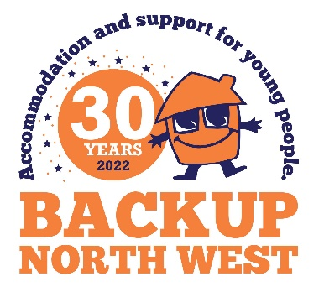

BOOKING FORM
Backup Golf Day
Friday 8th July 2022, Bolton Golf Club
Name of Team……………………………………………………………………………………………………………………………………..
Name of contact………………………………………………………………………………………………………………………………….
Contact no…………………………………………………………………………………………………………………………………………..
Email……………………………………………………………………………………………………………………………………………………
I would like to enter……(please indicate) Teams at £260 per team.
I would like to sponsor …..(please indicate) hole at a cost of £100 per hole.
I would like to donate a prize/prizes………………………………………………………………….
- Bacon butties from 10 – 10.30am
- 18 holes of golf for a team of 4
- Shotgun start at 12 noon
- Afternoon buffet
- Prizes and presentations
- On course drinks
HOW TO PAY
By Cheque to: By bacs:
Backup North West Sort code: 08-90-18
Ground and 1st floor Acc no: 70966608
77 Bridgeman Street (please reference your name and golf day)
Bolton BL3 6BY Cooperative Bank Backup North west
Competition rules.
Stableford scoring.
2 highest point scorers count per team of 4, except for hole 18 when all points scored by a team of 4 count.
Maximum handicap for men 24. Ladies 32.

