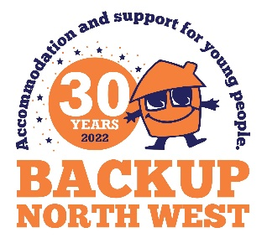 | Sponsorship and Gift Aid Declaration Form  Please sponsor (name of participant)----------------------------------------------------------------------  For taking part in Backup’s ‘Let’s Do 30 for £30 Challenge’  Date of Challenge:------------------------------------------------------------------------------------
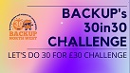
IMPORTANT INFORMATION GIFT AID DECLARATION Using Gift Aid means that for every pound you give, Backup Northwest Charity will get an extra 25p from HM Revenue & Customs
Remember: You must provide your full name, home address, postcode and tick the Gift Aid box for the Charity to claim tax back on your donation.

If I have ticked the box headed ‘Gift Aid? √’, I confirm that I am a UK Income or Capital Gains taxpayer. I have read this statement and want the charity or Community Amateur Sports Club (CASC) named above to reclaim tax on the donation detailed below, given on the date shown. I understand that if I pay less Income Tax / or Capital Gains tax in the current tax year than the amount of Gift Aid claimed on all of my donations it is my responsibility to pay any difference. I understand the charity will reclaim 25p of tax on every £1 that I have given.

Sponsor’s full name (First Name & Surname) | Sponsor’s home address (only needed if you are Gift Aiding your donation; don’t give your work address if you are Gift Aiding your donation) | Postcode (in full) | Donation  amount £ | Gift Aid ? | Date paid
Alex Sample | 123 Coronation Street | M22 0SE | £10 | √ | 01/08/19

Backup Northwest Charity Registered Charity no.1064698

