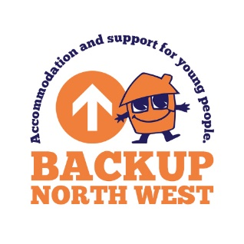
PRIVACY STATEMENT FOR BACKUP CANDIDATES

This Forms is an appendix of BACKUP’s GDPR General Data Protection Regulation Policy and Procedures

- BACKUP exercises its right under the General Data Protection Regulation (GDPR) to control and process personal information about candidates during the recruitment process. We process this data as it is necessary as part of the recruitment process.

- Your privacy is of the utmost importance to us, and data protection is built into our processing at every stage. This means that while we do not require your consent in order to process your personal data, we will only retain and use personal data when we have a legally justifiable reason for doing so that balances our interests as an employer with your rights as a candidate.

- Your personal data is shared only with those staff members, and external organisations who also have a legal basis for using it in order to fulfil our obligations to you as a candidate.

- We never sell or share your information with any organisations for marketing purposes.

- BACKUP do not use your personal data for any automatic profiling or decision making.

- You have the right to see what personal information BACKUP processes about you, and to know our reasons for doing so. In turn, BACKUP has an obligation to keep information about you accurate and up-to-date. If you become aware of any information we hold about you that is inaccurate, or if any of your personal details have recently changed, please notify us and we will update our records accordingly.

- You have the right to request to see all your personal information that BACKUP records and processes, formal requests should be made to businesssupport@backup-charity.org.uk.

- The types of personal information we process include:
- Personal details, i.e. Names, addresses, contact numbers, date of birth, NI number
- Family details, i.e. Marital status, next of kin and emergency contacts (including your GP)
- Nationality
- Whether you have a current driver’s licence
- Whether you are registered as disabled
- Bank account details

- We also process sensitive categories of personal information that may include:
- racial and ethnic origin
- trade union membership
- information about your mental or physical health, insofar as this pertains to your job role
- Sexual orientation

- BACKUP will not record or process information about your political or religious opinions, philosophical beliefs, sexual orientation or gender identity, or any other categories of personal information named in Article 9 of the GDPR, except where you have disclosed this information and given us your explicit consent to record and process it.

- You have the right to “data portability” with respect to your personal information, which means that you may request for it to be sent to you in a format that can be moved, transferred or copied across different services. Formal requests should be made to businesssupport@backup-charity.org.uk.

- In accordance with BACKUP’s data retention policy we will hold candidate’s data for six months following an unsuccessful application, at which point it will be securely deleted.

- You have the “right to be forgotten” with respect to your personal information which means you can request for us to securely delete information we hold on you at any time prior to the six month retention period outlined above. Formal requests should be made to businesssupport@backup-charity.org.uk.

- If you have any questions on BACKUP and your personal information, please contact our Data Protection Officer (DPO) which is our Director of Business.

- You have the right to log a complaint with the Information Commissioner’s Office (ICO) if you have any concerns about the way that BACKUP is using your personal information. More information can be found at the ICO’s website at https://ico.org.uk/concerns/ or by calling their helpline on 0303 123 1113.

